

Foundations of Programming

Assignment No.: 22
PROBLEM STATEMENT: Write a menu driven program in C to perform various string operations using in-built functions.

OBJECTIVE:

- To understand the concept of strings in the C programming language.
- To learn how to use built-in string functions for string manipulation.
- To perform operations such as length calculation, copying, concatenation, comparison, and reversal using menu options.
.

THEORY:
In the C programming language, a string is a sequence of characters terminated by a null character ('\0'). Strings are stored in character arrays and manipulated using functions available in the string.h header file.
Common built-in string functions include strlen() for finding the length of a string, strcpy() for copying one string to another, strcat() for concatenating two strings, and strcmp() for comparing two strings.
A menu driven program allows the user to select different operations from a list of options. Based on the user’s choice, the corresponding string function is executed. This approach makes the program interactive and easy to use.

PLATFORM: Linux
ALGO:
Step 1 : Start
Step 2 : Input string str1
Step 3 : Display menu
1. Length
2. Reverse
3. Concatenate
4. Compare
5. Copy
6. Exit
Step 4 : Input choice
Step 5 : If choice == 1 → strlen(str1), print length
Step 6 : If choice == 2 → strrev(str1), print reversed string
Step 7 : If choice == 3 → input str2, strcat(str1, str2), print result
Step 8 : If choice == 4 → input str2, strcmp(str1, str2), print result
Step 9 : If choice == 5 → strcpy(str3, str1), print copied string
Step 10: If choice == 6 → Exit
Step 11: Go back to Step 3
Step 12: Stop
FLOWCHART :
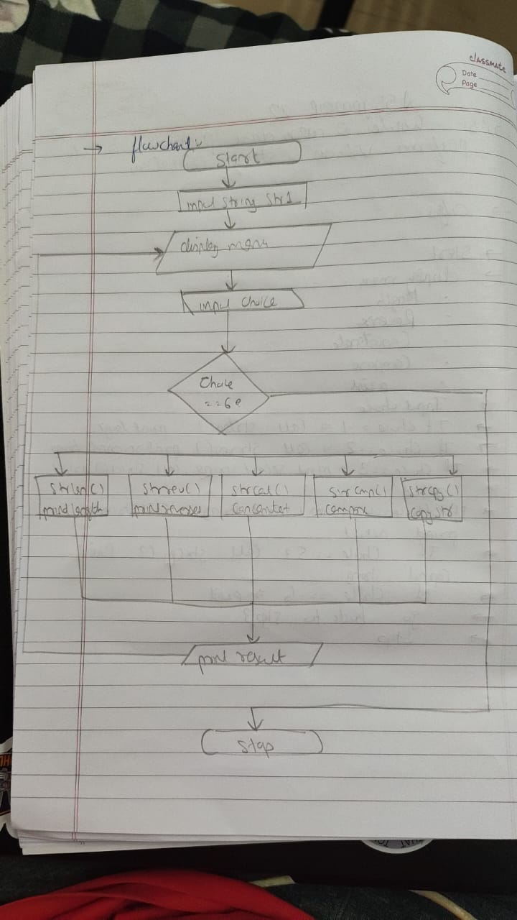

CODE :
#include <stdio.h>
#include <string.h>

// Custom reverse function (strrev not available in GCC/Linux)
void reverse(char *str) {
int n = strlen(str);
for (int i = 0; i < n / 2; i++) {
char temp = str[i];
str[i] = str[n - i - 1];
str[n - i - 1] = temp;
}
}

// Fix fgets: removes trailing newline
void readString(char *str) {
fgets(str, 100, stdin);
str[strcspn(str, "\n")] = '\0';
}

int main() {
char str1[100], str2[100], str3[100];
int choice, result;

printf("Enter primary string: ");
readString(str1);

do {
printf("\n===== STRING OPERATIONS MENU =====");
printf("\n1. Length of string");
printf("\n2. Reverse of string");
printf("\n3. Concatenate two strings");
printf("\n4. Compare two strings");
printf("\n5. Copy string");
printf("\n6. Exit");
printf("\nEnter your choice: ");
scanf("%d", &choice);
getchar();

switch (choice) {

case 1:
printf("Length of \"%s\" = %zu\n",
str1, strlen(str1));
break;

case 2:
strcpy(str3, str1);
reverse(str3);
printf("Reversed string = %s\n", str3);
break;

case 3:
printf("Enter second string: ");
readString(str2);
strcat(str1, str2);
printf("Concatenated string = %s\n", str1);
break;

case 4:
printf("Enter second string: ");
readString(str2);
result = strcmp(str1, str2);
if (result == 0)
printf("Strings are EQUAL\n");
else if (result < 0)
printf("str1 is LESS than str2\n");
else
printf("str1 is GREATER than str2\n");
break;

case 5:
strcpy(str3, str1);
printf("Copied string = %s\n", str3);
break;

case 6:
printf("Exiting program...\n");
break;

default:
printf("Invalid choice! Please try again.\n");
}

} while (choice != 6);

return 0;
}
INPUT: Two strings entered by the user.

OUTPUT:

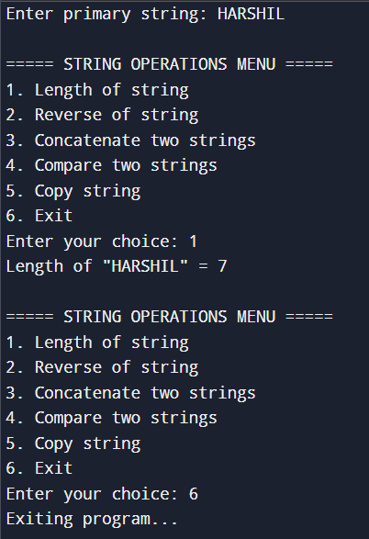

SAMPLE INPUT:
Enter first string: Hello
Enter second string: World
Choice: 3

SAMPLE OUTPUT:
Concatenated string: HelloWorld
CONCLUSION: Thus, the C program successfully demonstrates different string operations using built-in functions through a menu driven approach, making the program interactive and easy to use.

FAQs:
- What are built-in string functions in C and why are they used?
- What is the purpose of the string.h header file in C programs?
- How does a menu driven program improve user interaction in programming?

